**Dynamic Patient Flow Model for Predicting Demand Volumes and Sales in Oncology that incorporates Patient Journey and lines of therapy**

**Importance of Forecasting**

Forecasting plays a crucial role in the pharmaceutical industry, driving strategic decision-making and operational efficiency across multiple domains. It involves analyzing historical data, conducting market research, and considering factors like disease trends, patient needs, competition, and patient experiences. The primary goal is to enable companies to make informed decisions about production, inventory, pricing, and marketing.

In research and development, accurate forecasting helps companies allocate resources effectively, prioritize projects, and align with emerging therapeutic needs. This foresight optimizes R&D efforts, enhances product development success, and ensures market acceptance. Forecasting also helps assess whether investments in drug development are justified by projected returns, allowing for better resource allocation and project prioritization.

Beyond R&D, forecasting influences marketing by anticipating trends and efficiently allocating resources across sales and advertising initiatives. It also serves as a basis for setting targets and incentives, aligning workforce efforts with organizational goals and market projections.

Precise forecasting optimizes supply chains by minimizing inventory costs and ensuring seamless operations. Major pharmaceutical companies have achieved significant reductions in inventory costs through advanced forecasting methods, and smaller firms benefit from partnerships with analytics providers.

Forecasting aids in regulatory compliance by predicting approval timelines, facilitating timely product launches and maximizing market exclusivity. It also serves as a tool for risk mitigation, helping companies identify and prepare for market disruptions, enhancing resilience and adaptability in a competitive market.

Additionally, forecasting involves anticipating regulatory approvals and market access, predicting how regulatory reviews will affect product availability and market penetration. Evaluating the impact of health technology assessments and comparative effectiveness research on product adoption is also essential. By integrating robust forecasting methodologies, pharmaceutical companies can drive innovation, streamline operations, and mitigate risks effectively.

**The Unique Complexity of Oncology Forecasting**

Forecasting in oncology represents one of the most complex challenges facing pharmaceutical companies today. The unique characteristics of cancer treatment pathways, coupled with evolving therapeutic landscapes and patient-specific variables, create a multifaceted forecasting environment unlike any other disease area. Oncology forecasting differs fundamentally from forecasting in other therapeutic areas due to its inherent complexity and multidimensional nature. While primary care therapies for conditions like cardiovascular or metabolic diseases can be predicted based on population statistics and historical trends, oncology requires a far more nuanced approach.

According to Nature.com (Nature Reviews in Clinical Oncology), US spending on oncology therapies reached $99 billion and is projected to increase to nearly $180 billion in 2028. This exponential growth has made accurate forecasting even more critical for pharmaceutical companies.

Cancer treatment decisions are guided by numerous factors including tumor type, disease stage, genetic markers, and previous treatment responses. Oncologists develop personalized treatment pathways based on these criteria to optimize patient outcomes at each stage of the disease. This creates an intricate forecasting challenge where patient segmentation becomes extremely granular. The oncology treatment landscape is further complicated by products approved across multiple indications, combination therapy regimens, varying dosing schedules, and treatment adjustments due to toxicity issues.

The progressive nature of cancer introduces additional complexity to forecasting efforts. Patients move through different lines of therapies and disease stages, with eligibility for treatment options changing at each point. Prior therapy use significantly impacts future treatment eligibility, as many oncology drugs have restrictions preventing repeated use in the same patient. These line of therapy reductions must be carefully modeled to avoid overestimating product usage.

Treatment pathways in oncology are seldom linear, with patients experiencing variable patterns of disease progression, remission, and relapse. High toxicity profiles of certain agents often necessitate regimen adjustments within a single line of therapy, creating additional variability in usage patterns. Forecasting models must account for these dynamic treatment pathways and incorporate sophisticated patient flow modeling to capture the entirety of the patient journey from diagnosis through multiple treatment lines.

**Limitations of Current Models and Balancing Supply Chain Considerations**

Currently available forecast models for oncology drugs have always failed to accurately predict the demand as pharmaceuticals companies just tend to use patient numbers which always results in over or under forecasting the disease burden.

For pharmaceutical companies, accurate forecasting is essential not only for financial planning but also for ensuring appropriate drug supply. The complex manufacturing processes for many oncology drugs, particularly biologics, require significant lead time and resource allocation. Over-forecasting results in wastage and substantial financial write-offs due to limited shelf life, while under-forecasting can leave patients with life-threatening conditions unable to access needed therapies.

This balancing act represents a critical unmet need in oncology forecasting.

**The Importance of Patient Journey Mapping in Oncology Forecasting**

Accurately forecasting oncology drug demand requires detailed mapping of the patient journey from initial diagnosis through various treatments over time. This approach, often referred to as "Patient Journey" analysis, involves classifying patients into specific subgroups and tracking their progression through the healthcare system. The first key step in building an effective forecasting capability is mapping out the oncology patient journey and prioritizing key events critical for brand success.

Patient flow models have distinct advantages in oncology forecasting as they capture a patient's entire treatment process, effectively model market complexities, and incorporate the various drivers and decision-makers that determine treatment paths. These models provide a holistic view of the oncology environment and can incorporate dynamic rather than static input parameters, allowing for more accurate projections.

Creating an effective patient flow model requires identifying numerous input variables and gathering substantial information from market research, real-world data, and clinical trial results. The quality of these inputs represents the single most important factor in developing an accurate forecast. However, implementing such models requires significant resources and expertise, making it challenging for some organizations to fully leverage this approach.

**Dynamic Patient Flow Forecast Model Incorporating Patient Journey**

This new innovative sophisticated model goes beyond traditional forecasting methodologies by merging complex forecasting techniques with “Patient Journey”. The multidimensional patient-centric model incorporates complex interplay of patient characteristics, treatment pathways, emerging therapies and provides the ability to perform sensitivity analysis and scenario planning for managing forecast uncertainty. Below is a structure of the forecast platform with development stages.

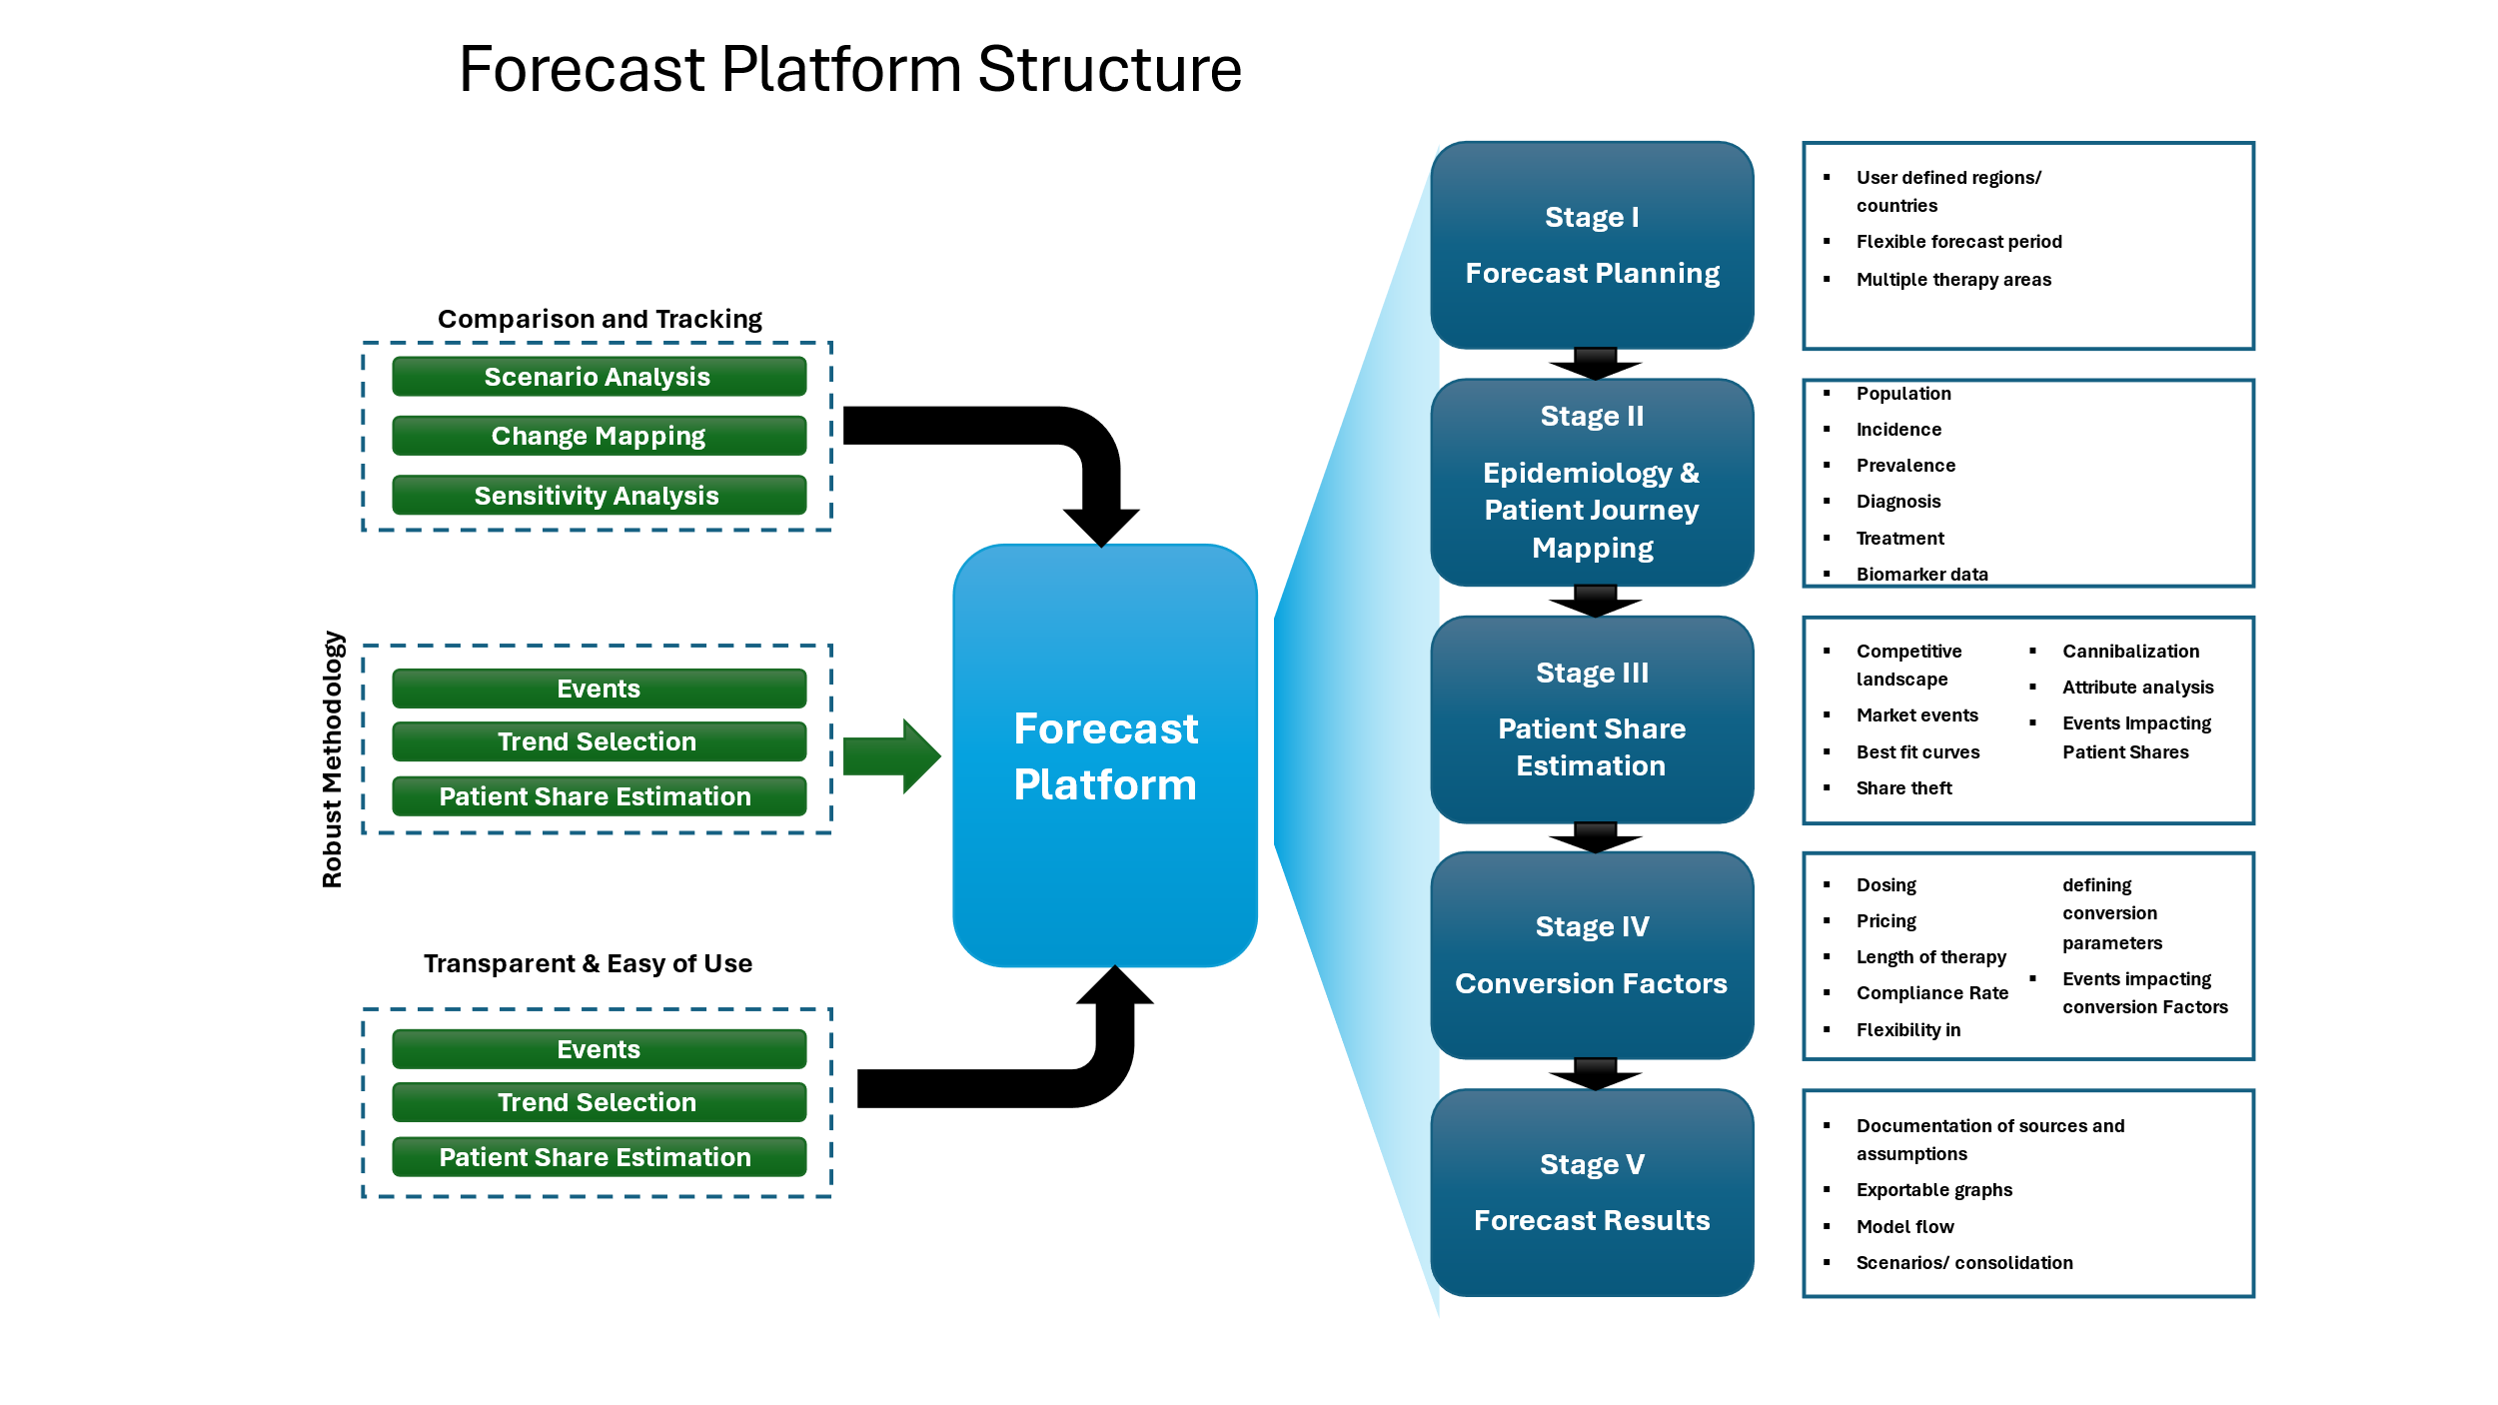

The model incorporated multiple variables and complex data within the “Patient journey”. These include factors such as diagnosis, incidence, recurrence, stage of cancer, lines of therapy. The model also has the ability to segment patients by splitting them into smaller groups with similar characteristics and dynamically maps patients through different stages and lines of treatment as they progress through the disease. An example of patient flow is illustrated below.

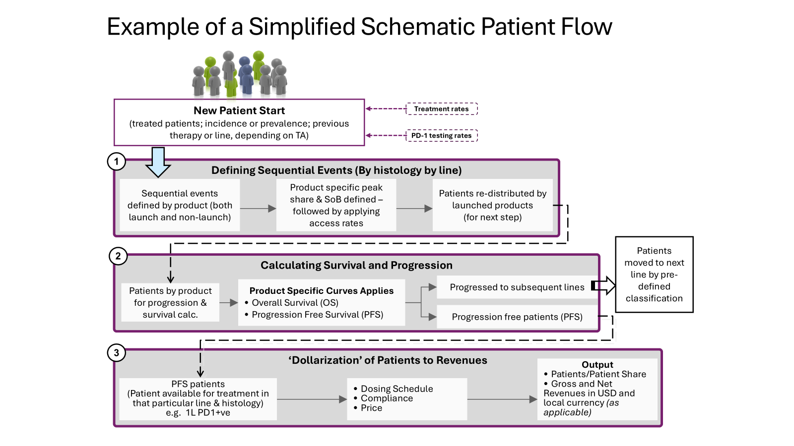

Time granularity is also a key aspect of this model where the forecast is split by months for greater flexibility to include market or competitor events. From an eagle’s eye perspective, my model simulates a specific cancer market by integrating patient journey, historical data, new competitor approvals and clinical trial results. Advanced statistical techniques – linear and multiple regression are used to identify patterns and predict future values.

In terms of scalability, the model can be used across multiple tumor areas such as lung cancer, breast cancer, melanoma, colorectal cancer, bladder cancer, multiple myeloma, prostate cancer, etc. From a results/value addition perspective, the dynamic patient flow model has improved decision making with an accuracy of more than 90% which is a new benchmark and never seen so far in the industry. Below are a few snap shots of the model.

